EcoCONNECT POLICY BRIEF

## Table of Contents

**Table of Contents 1**

**1.0 Executive Summary 2**

**1.1 Problem Statement 2**

**1.1.1 Climate Risks to Rural Livelihoods 2**

**1.2 Weak Civic Feedback 4**

**1.3 EcoConnect as a Solution 4**

**1.4 Policy Recommendations 12**

**1.5 References 13**

## **1.0 Executive Summary**

* EcoConnect is a comprehensive climate-tech platform designed to empower rural African communities, in this case Nigerian to be specific, by enabling real-time reporting of environmental hazards, supporting youth eco-entrepreneurs, and institutionalizing civic feedback. The app functions via both smart phone and offline SMS/USSD, ensuring accessibility even in low-connectivity regions. Available in English, Pidgin, Hausa, and other local languages, EcoConnect is built for inclusivity.
* It was conceived in response to:

1. Intensifying floods, droughts, erosion, and desertification impacting agriculture and livelihoods;
2. The widespread exclusion of youth from green innovation ecosystems, and;
3. Weak civic feedback mechanisms preventing grassroots voices from influencing policy.

* Targeting smallholder farmers, young rural innovators, and local governance entities, EcoConnect seeks to:
* Facilitate community-driven climate alerts (e.g., "FLOOD GBAKO");
* Nurture green enterprises via training and funding referrals, and;
* Channel community insights into policy feedback loops.
* By democratizing climate data, catalyzing green job creation, and closing civic feedback gaps, EcoConnect aspires to transform rural climate resilience in Nigeria.

## **1.1 Problem Statement**

### **1.1.1 Climate Risks to Rural Livelihoods**

* Flooding: As reported by Reuters international, the recent floods experienced in Nigeria over the past two years have displaced over 1.4 million people and destroyed over 110,000 hectares of farmland, costing thousands of lives and infrastructural loss.[1] These floods not only cause economic loss but also cause mass starvation the to society since it destroys farmlands and also carries away livestock, which are key sources of sustenance to local communities.
* In 2025, severe rains in Mokwa City, Niger State, caused flash floods killing over 200 people and displaced over 3,000 families.[2] Experts said that the floods were caused by climate change, unregulated construction and poor drainage infrastructure.[3] These was exacerbated due to poor drainage and infrastructure. Additionally, lack of information and awareness was a great contributor to these fatalities. For example, as reported by Reuters International, in Borno, the Alau dam, upriver from Maiduguri, gave way on September 9 2024, four days after state officials had told the public it was secure. This misinformation caused great harvoc to the local communities.[4]
* Drought & Heat: Prolonged dry spells in Sokoto and Adamawa areas limit irrigation, threatening smallholder farmers who contribute 90% of Nigeria’s food basket. This therefore exposes Nigeria’s food security to an existential threat for lack of sufficient food in the near future. Already, 25 million people live in acute food and nutrition insecurity - putting their lives or livelihoods in immediate danger, according to a joint analysis by the government and U.N. agencies.[5]
* Erosion & Desertification: Northern Nigeria loses 350,000 hectares annually to desertification, south-east battles gully erosion impacting farms and homes.[6] If not curbed, this poses to threaten the green cover of Nigeria, driving it into an arid and semi arid region, which will not be conducive for agriculture, thereby threatening Nigeria’s food security.

## **1.2 Weak Civic Feedback**

* One of the major causes of this existential risks to the local communities is due to lack of timely awareness. This is caused due to a lack of civic involvement and feedback. Rural communities are perceived to be aware of climate risks but lack channels to influence planning. As illustrated above, in Borno, local residents were exposed to an over-flooded river due to misleading information that they received from a biased government source. The local community did not get credible and factual information about the situation of the river and the existent risks. The information relayed to them was also not sufficient and was not timely, thereby putting their livelihoods into jeopardy.

## **1.3 EcoConnect as a Solution**

* EcoConnect aims to provide a solution to this existential threat and emerging risks of climate change to the local communities. Since one of the major flaws that exacerbates exposure to these risks is a lack of awareness due to weak civic involvement, EcoConnect seeks to bridge this gap by providing an avenue which provides a link between stakeholders and the affected local communities/ residents. Local residents will have an accessible, affordable and available means to report real-time crowd-sourced data on floods, droughts, erosion and deforestation. EcoConnect seeks to achieve this through the following features;

1. **Dual Access: Online & Offline**

* EcoConnect will be available both online and offline. It will be available in smart phones and any other devices. In the online feature, the app can be applicable through a mere cursory search at any research engine, this will showcase the website of the app to the user and all the available features will be visible.
* In the offline model, the contents of the app can be available through an SMS or through dialing a given USSD. This will enable Offline reporting, which bridges the network connectivity gap as it will be available in remote areas. The text will be simple and short for understanding; (e.g., FLOOD GBAKO). Additionally, the contents of the app and the messages can be accessed in any language as the app will have a multilingual support feature. This simplifies and softens the users’ experience with the app, preventing any language barrier issues.

***Below is a pictorial representation showing the overview/ dashboard of EcoConnect.***

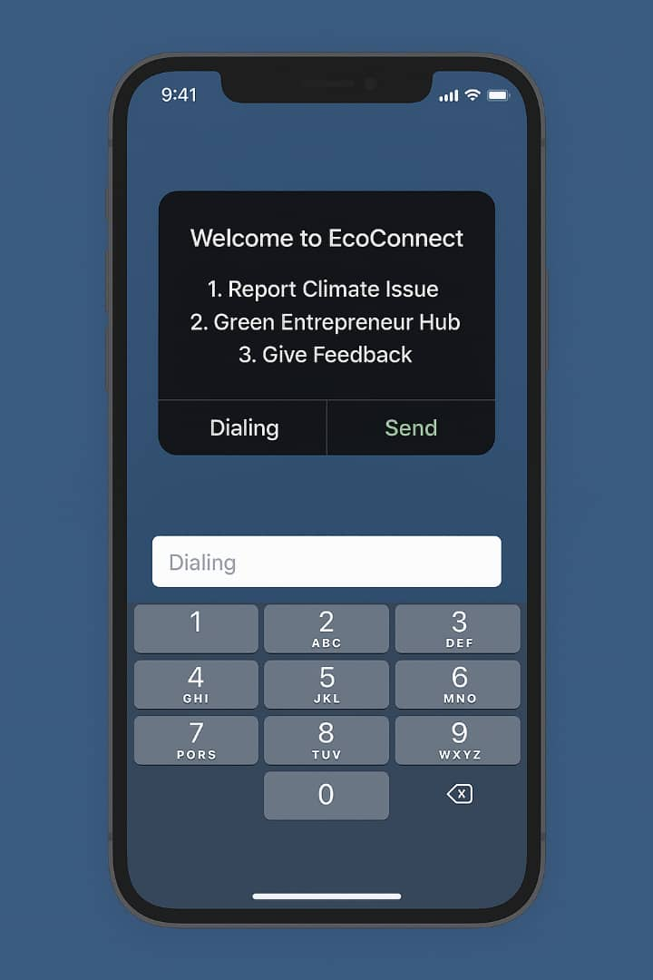

***Below is a pictorial representation showing a sample text message that can be sent as an alert;***

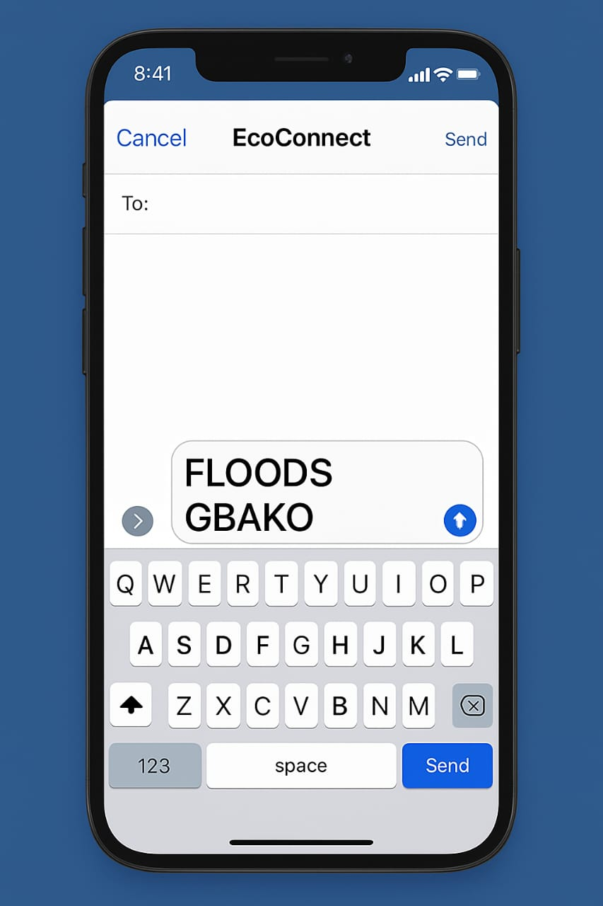

**ii) Climate Issue Reporting**

* As has been stated, local residents will have the opportunity to report any existential risk or threat associated with climate change. Users can do this through its salient features; that is through dialing the USSD code, sending an SMS or reporting the issue online through the website of EcoConnect.

***Below is a pictorial representation showing the Climate Reporting Feature in EcoConnect.***

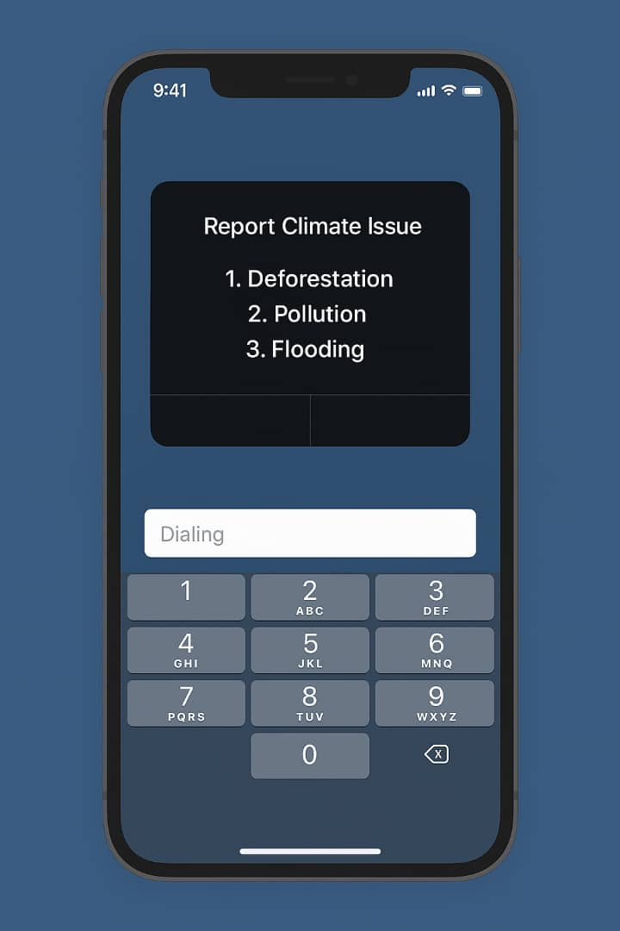

* For users who are not comfortable with text messages, they can simply upload photos/ images of the risk they are facing and the same will be reviewed by the stakeholders on the receiving and relevant action will be taken. Users can also pin their live GPS location for traceability. For offline users, an SMS tag accompanied with a location via USSD will do.

***Below is a pictorial representation showing the option for choosing locations for easier traceability;***

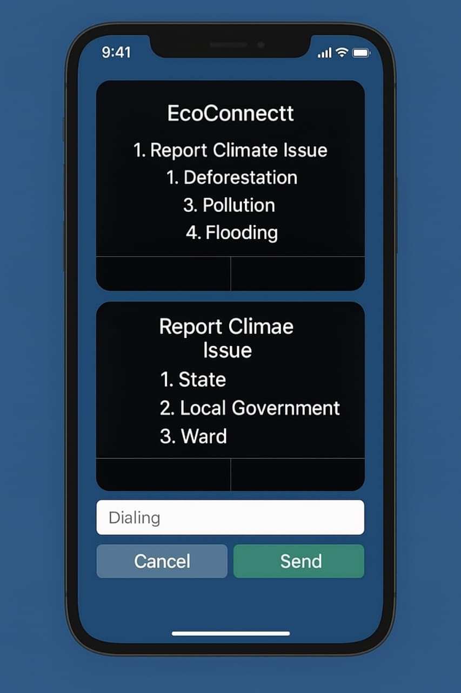

**iii) Green Hustle Corner**

* In an effort to mitigate the risks associated with climate change, EcoConnect also seeks to empower the youths through training them on how to face climate change risks and how to mitigate them. This will be under the Green Entrepreneur Hub. This will ensure that youths acquire the necessary knowledge of how to prevent climate change risks from happening and also to mitigate the risks, when they happen. As usual, prevention is better than cure. This section will contain a repository for eco-preneur training, micro-grant access, and a market showcase.

***Below is a pictorial representation showing the EcoConnect Repository and its contents;***

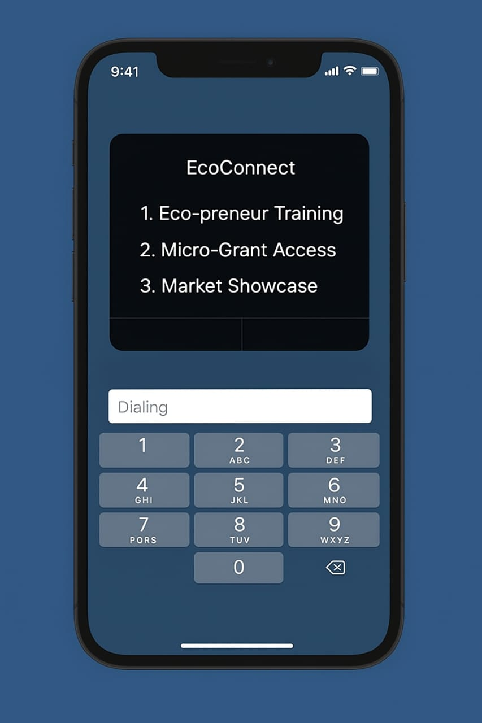

* Apart from the training, it will connect youths to green opportunities and green jobs. By doing this, the app will be killing two birds with one stone as it will be curbing youth unemployment and will also be aiding in fighting climate change, through connecting youths to opportunities that are critical in the fight for climate change. It will also connect youths to federal youth initiatives and youth empowerment programmes and movements which aid in fighting climate change. This will create awareness and be the basis of an informed citizenry on climate change matters.

**iv) Civic Feedback System**

* The app will also provide structured feedback forms for community members to flag policy gaps, infrastructure needs, or request resources. This will be under the Give Feedback Option. It will provide a repository for data compiled into public dashboards and routed to local government authorities and Federal Ministry platforms. This will bridge the gap between the local communities and the relevant stakeholders associated with climate change. Local communities will get the opportunity to decide what they want to be done, according to their priority. For example, in flood prone areas, local members may prioritize building of bridges and dams, while local communities in drought prone areas may prioritize construction of water reservoirs and provision of irrigation systems.

***Below is a pictorial representation showing the Civic Feedback System;***

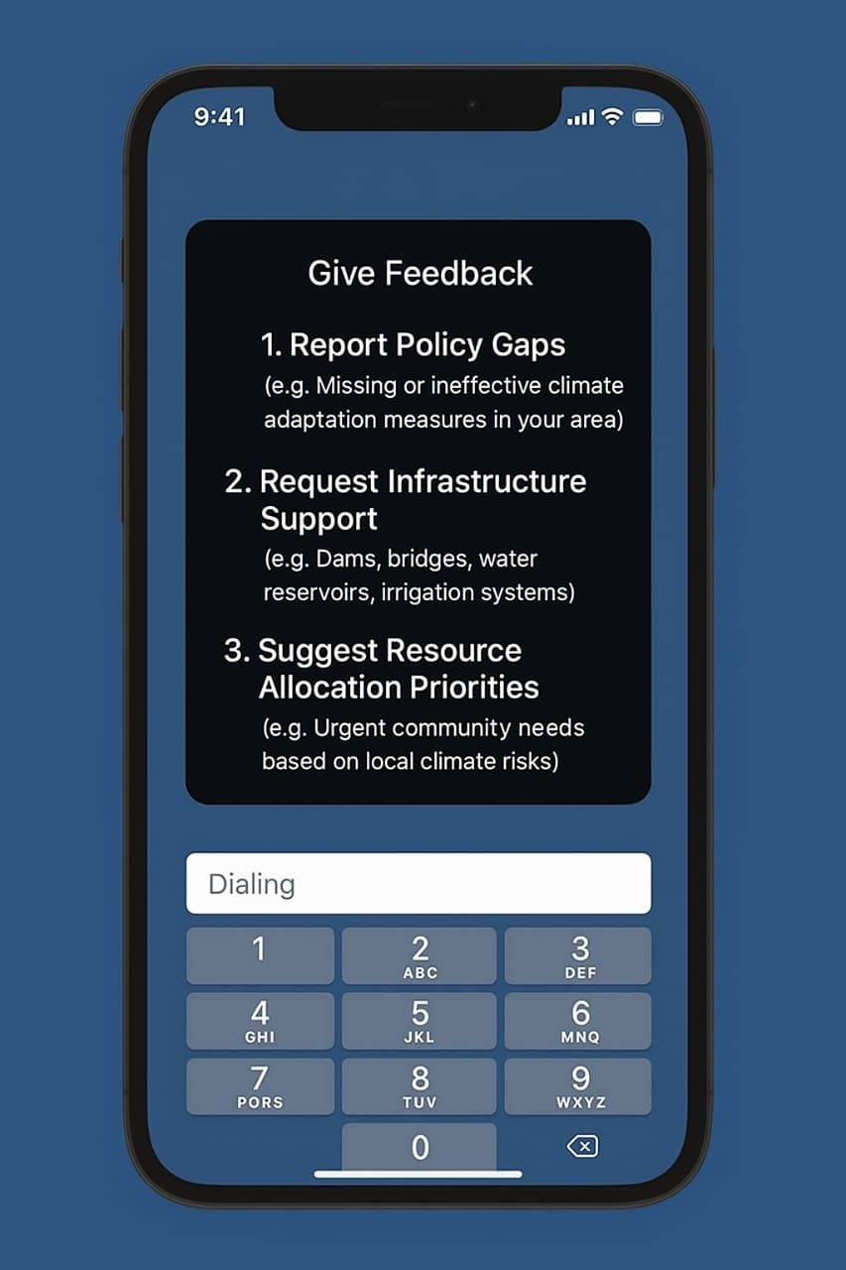

## **1.4 Policy Recommendations**

**i) Strategy Action Points**

* This application’s strengths will be driven by Community-Driven Climate Intelligence in that any climate change related issue that will happen in any region and witnessed by anyone can be reported first hand by that person. We therefore call for the institutionalization of this platform in local government disaster systems and federal government disaster systems.
* Youth Empowerment in Green Innovation; The government can launch seed grants and training schemes for app-registered youth. The government can also harness this golden opportunity and embed government sponsored green enterprise modules and vocational curriculum into EcoConnect so that users can easily access them.
* Institutionalized Civic Feedback; The government, in an effort to legitimize the feedback and involvement of people in the application, should enact laws requiring local government authorities to respond within 30 days to civic submissions and publish annual impact reports.
* SMS/USSD Infrastructure Expansion; The government and relevant stakeholders should partner with telecoms to waive SMS fees, deploy USSD reporting codes across Nigeria’s 36 states and also ensure access to cheap and affordable internet so that affected communities can access the website of EcoConnect and the application, thereby facilitating a wider outreach.

## **1.5 References**

# 1. Ope Atedayo, ‘Floods in Nigeria kill at least 49, displace thousands’, Reuters International, 26 August 2024, -<<https://www.reuters.com/world/africa/floods-nigeria-kill-least-49-displace-thousands-2024-08-26/kkk>> on 9 June 2025.

2. Al Ja Zeera News, ‘Nigeria Flash Floods: Which is the most affected area, what caused the deluge?’ Al Jazeera News, 1 June 2025, -<[Nigeria flash floods: Which is most affected area, what caused the deluge? | Floods News | Al Jazeera⁤](https://www.aljazeera.com/news/2025/6/1/nigeria-flash-floods-which-is-most-affected-area-what-caused-the-deluge)>, on 9 June 2025.

3. Al Ja Zeera News, ‘Nigeria Flash Floods: Which is the most affected area, what caused the deluge?’

4. The Straight Times, ‘Millions of Nigerians go hungry as floods compound hardship’, The Straight Times, 13 November 2024, -<[Millions of Nigerians go hungry as floods compound hardship | The Straits Times](https://www.straitstimes.com/world/millions-of-nigerians-go-hungry-as-floods-compound-hardship)>, on 9 June 2025.

5. The Straight Times, ‘Millions of Nigerians go hungry as floods compound hardship’.

Babaji Usman, ‘How deforestation is causing devastating impacts in Nothern Nigeria’, Wikkitimes.com, -<[Northern Nigeria is in the grip of a severe desertification crisis](https://wikkitimes.com/how-deforestation-is-causing-devastating-impacts-in-northern-nigeria/)>, on 9 June 2025.

**[Prepared by Climate and Sustainability Thematic Group]**

1. # Ope Atedayo, ‘Floods in Nigeria kill at least 49, displace thousands’, Reuters International, 26 August 2024, -<<https://www.reuters.com/world/africa/floods-nigeria-kill-least-49-displace-thousands-2024-08-26/kkk>> on 9 June 2025.

  
2. Al Ja Zeera News, ‘Nigeria Flash Floods: Which is the most affected area, what caused the deluge?’ Al Jazeera News, 1 June 2025, -<[Nigeria flash floods: Which is most affected area, what caused the deluge? | Floods News | Al Jazeera⁤](https://www.aljazeera.com/news/2025/6/1/nigeria-flash-floods-which-is-most-affected-area-what-caused-the-deluge)>, on 9 June 2025.
3. Al Ja Zeera News, ‘Nigeria Flash Floods: Which is the most affected area, what caused the deluge?’
4. The Straight Times, ‘Millions of Nigerians go hungry as floods compound hardship’, The Straight Times, 13 November 2024, -<[Millions of Nigerians go hungry as floods compound hardship | The Straits Times](https://www.straitstimes.com/world/millions-of-nigerians-go-hungry-as-floods-compound-hardship)>, on 9 June 2025.
5. The Straight Times, ‘Millions of Nigerians go hungry as floods compound hardship’.
6. Babaji Usman, ‘How deforestation is causing devastating impacts in Nothern Nigeria’, Wikkitimes.com, -<[Northern Nigeria is in the grip of a severe desertification crisis](https://wikkitimes.com/how-deforestation-is-causing-devastating-impacts-in-northern-nigeria/)>, on 9 June 2025.